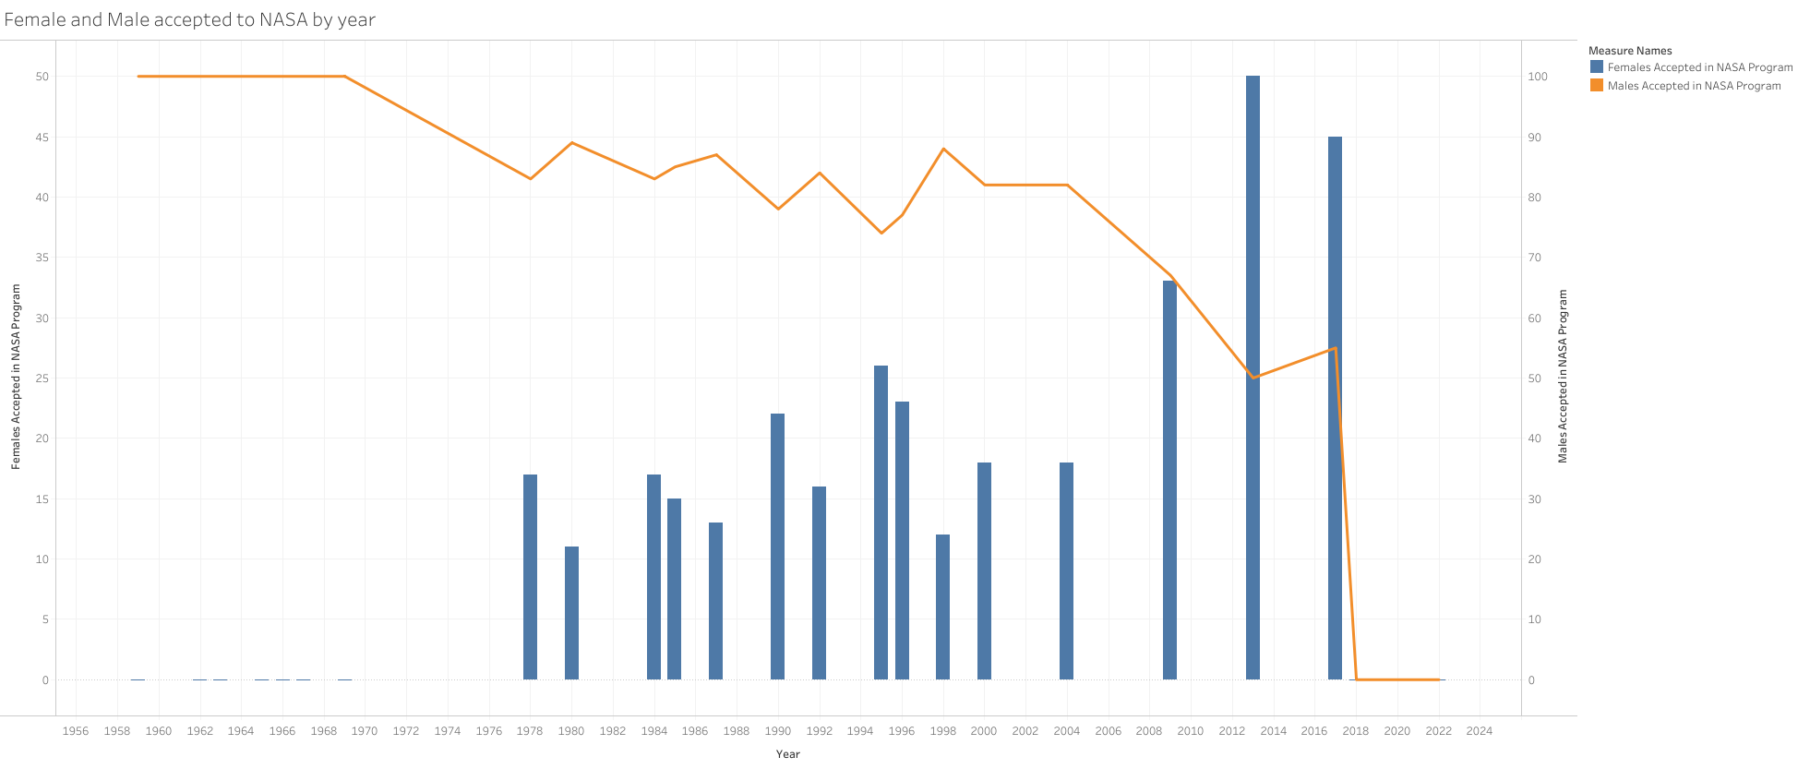

1. What is the difference between men getting accepted versus women?
2. Do more women or men get hired when the budget is hire or lower?
3. Does the budget have an effect to whether how many men versus women will get accepted?

